Project Design Phase-II
Data Flow Diagram

Date | 02 February 2026
Team ID | LTVIP2026TMIDS55759
Project Name | Strategic Product Placement Analysis: Unveiling  Sales Impact with Tableau Visualization
Maximum Marks | 3 Marks

Data Flow Diagrams:
A Data Flow Diagram (DFD) is a traditional visual representation of the information flows within a system. A neat and clear DFD can depict the right amount of the system requirement graphically. It shows how data enters and leaves the system, what changes the information, and where data is stored.

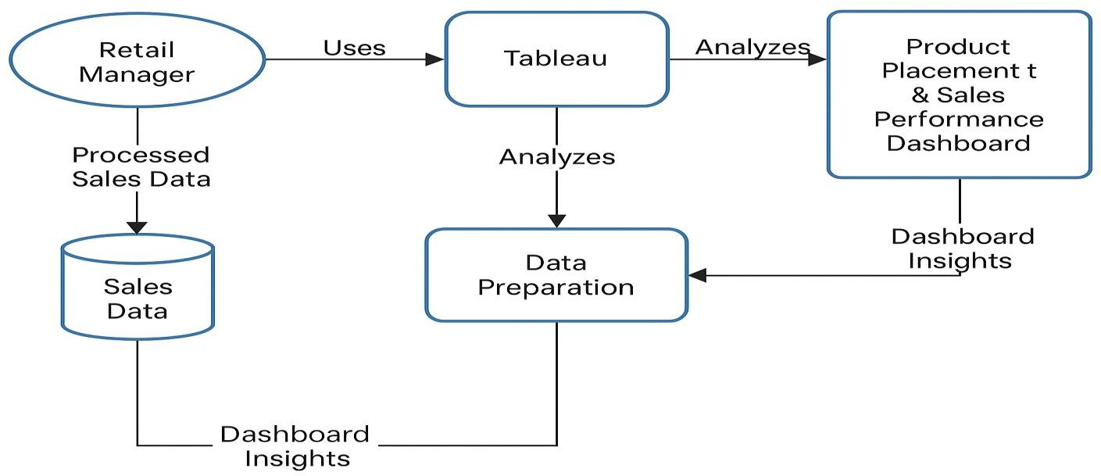

User Stories:

User Type | Functional Requirement  (Epic) | User Story Number | User Story / Task | Acceptance criteria | Priority | Release
Retail Manager | Interactive Dashboard | USN-1 | As a Retail Manager, I want to view product sales by store and category so that I can understand placement effectiveness. | Able to filter sales by store, product, and region  with charts updating dynamically. | High | Sprint-1
Business Analyst | Sales Performance Metrics | USN-2 | As a Business Analyst, I want to track KPIs like revenue, units sold, and trends over time to support decision-making. | Dashboard displays KPIs in clear cards with trend lines for the past 3 months | High | Sprint-1
Marketing Analyst | Product Comparison | USN-3 | As a Marketing Analyst, I want to compare product performance across placements to optimize store layouts. | Able to view side-by-side comparisons by shelf  location and placement strategy. | Medium | Sprint-1
Sales Executive | Access Control | USN-4 | As a Sales Executive, I want role-based access so that sensitive data is protected based on user roles. | Each user sees only data allowed for their role (Sales, Analyst, Manager) | High | Sprint-1
Data Engineer | Data Preparation and ETL | USN-5 | As a Data Engineer, I want to clean and load sales data into Tableau in a structured format. | Data sources are connected, cleaned using Tableau Prep, and correctly populate the  dashboard. | High | Sprint-1
Stakeholder | Summary Insights View | USN-6 | As a Stakeholder, I want a quick summary view with top insights so that I don’t have to explore every detail. | Summary section with 3-5 key takeaways auto- generated at top of  dashboard. | Medium | Sprint-1
Analyst | What-If Scenario Tool | USN-7 | As a Analyst, I want to simulate placement changes and see potential impact on sales. | Can input hypothetical placement, run simulation, and view projected KPI  changes. | Low | Sprint-2

